

Cable Avoidance

A Simple Guide



**The Ten Golden Rules of Locating**

**1 Obtain Plans and walk the site to check for obvious signs of utilities**

**2 Use safe digging practice**

**3 Use the C.A.T upright - NEVER swing it!**

**4 Use Power and Radio to sweep the whole area**

**5 Use the sensitivity control correctly to pinpoint the conductor**

**6 Use the C.A.T again in the trench/hole once you have excavated approximately 0.3 m (1 ft) to locate deeper or smaller services not locatable from the surface**

**7 Remove the speaker when using the C.A.T in noisy environments**

**8 Remember the C.A.T alone cannot always locate every conductor including small services and**

**street lighting - use the Genny**

**9 Remember the C.A.T will only trace metallic conductors and not plastic pipes or fibre optic**

**cables for example**

**10 Maintain your C.A.T and Genny regularly to ensure continued trouble free performance**

**Do not assume CAT’s find all utilities**

**Use plans**

**Mark outside excavation area**

**Use CAT in all different modes**

**Use Genny to verify utilities found**

**Repeat scan every 300mm**

**Never assume area is clear of services**

**Always Safe dig**



**Power**

**Radio**

**Avoidance (Radio detection)**

**Direct connection**

**Induction**

**Accessories**

**Safe Digging**

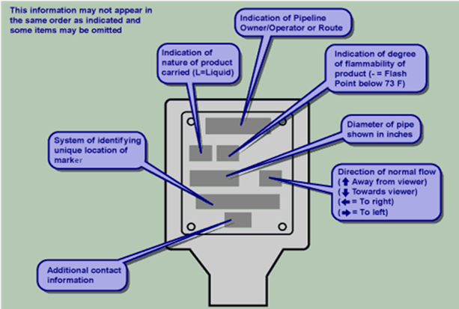

* **Planning, Permits & Risk Assessments**
* **Plans & Visual Survey**
* **Mark excavation area**
* **Check CAT function & calibration**
* **Grid or Sweep area**
* **Mark clearly (waterproof paint)**
* **Trial hole**
* **Safe dig**
* **No power tools within 500mm**
* **Rescan every 300mm**
* **Street lighting LIVE when NOT illuminated**
* **NO SIGNAL**

