**ROLE OF THE “TOP MAN”**

* **Never leaves post**
* **Maintains communication – he controls everything, ladder check, gas readings, when people climb or descend**
* **Checks safety equipment**
* **Conducts briefing – Emergency procedure**
* **Responsible for summoning help**
* **Briefing of Emergency Services**
* **Records people IN and OUT**
* **Conducts Head count**
* **Top Man controls when people unhook or climb**
* **Records gas readings – historical record**
* **Records kept for 5 years – someone else may need to go in**
* **Records for individual kept for 40 years**

Confined Space

A Simple Guide



* **A confined space means any place, including any**

**Chamber, Tank, Vat, Silo, Pit, Trench, Pipe, Sewer, Flue**, **Well or other similar space in which by virtue of its enclosed nature, there arises a reasonably foreseeable specified risk**

**Under the Regulations a “Confined Space” has two defining features**

1. **It is a place which is substantially (though not always entirely) enclosed**
2. **There will be a reasonably foreseeable specified risk of serious injury from hazardous substances or conditions within the space**

**15 people die in confined spaces in the UK every year**

**EMERGENCY PROCEDURES**

* **“Gas gas gas!” Don EBA Evacuate**
* **“Fire fire fire!” Don EBA Evacuate**
* **“Flood flood flood!” Don EBA Evacuate**
* **Do not stop to assist – evacuate**
* **Roll onto side – NO EBA**
* **No contact –** 
  1. **“Man Down Man Down Man Down!”**
* **Loss of Comms – Top Man calls 3 times then raise the alarm**
* **The Top Man NEVER enters the space**

**HAZARDS**

* **Flammable substances**
* **Oxygen enriched atmospheres**
* **Oxygen deficient atmospheres**
* **Toxic atmospheres**

**3 Types of Atmosphere**

* 1. **Flammable**
  2. **Toxic**
  3. **Suffocating**

.

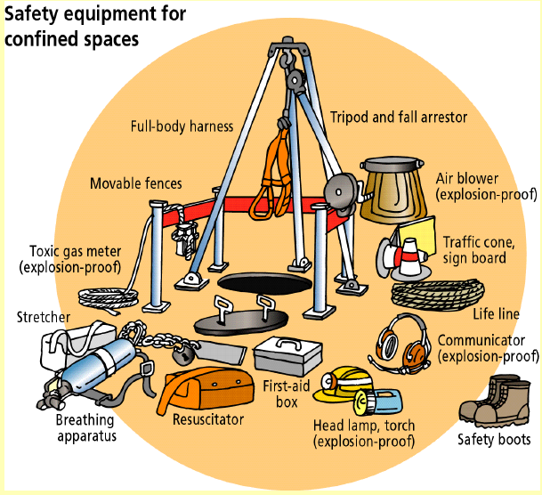

**FLAMMABLE ATMOSPHERES**

* **Lower Explosive Level (LEL)**
  1. **The LEL is the lowest concentration of fuel in air which will burn**
  2. **This ratio in a large number of cases is very small**
  3. **There is a high risk of explosion even with small concentrations of gas or vapour**
* **Upper Explosive Level (UEL)**
* **The UEL is the maximum concentration of fuel in air which will burn**
* **Concentrations above the UEL will not normally burn because the mixture is too rich**

**MEDIUM RISK**

* **Entry to the confined space may involve manual and/or mechanical access equipment**
  1. **Vertical entry normally using a ladder or man-riding winch**
     1. **Both requiring fall protection and means of assisted rescue such as a rescue winch**
  2. **Horizontal entry such as walking or climbing into the confined space or working away from the bottom of a vertical entry**
     1. **With limited use of a rescue line**
* **May involve traversing**
  1. **Requirements for permits**
  2. **Isolations and lockouts**
* **Equipment may include**
  1. **Tripods**
  2. **Winches**
  3. **Fall arrest blocks**
  4. **Harnesses**
  5. **Escape sets**
  6. **Gas detectors**

**GAS AWARE**

* **Turn on in fresh air**
* **Vent for 15 minutes**
* **30 seconds swivel at the entrance**
* **30 seconds swivel half way down**
* **5 minutes at the bottom**

