* **As a guide, only use a ladder or a stepladder:**
  1. **In one position for a maximum of 30 minutes**
  2. **For “light work” – they are not suitable for strenuous or heavy work**
  3. **Where a handhold is available on the ladder or stepladder**
  4. **Where you can maintain *three points of contact* at the working position**
* **Ladders should be put up at the correct angle of 75°**

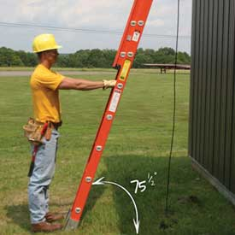

Ladders

A Simple Guide



**Remember: STEP**

**Site**

**Task**

**Equipment**

**People**

* **Ladders used for access to another level should be tied**
* **They must extend at least 1m above the landing point**
* **Ladders:**
  1. **Don’t use the top 3 rungs**
* **Steps:**
  1. **Don’t use the top 2 steps – unless it has a suitable handrail**
  2. **Don’t use the top 2 steps of swing back or double sided steps**
* **NEVER** **Descend with your back towards the ladder or stepladder**

**Ladder Classification**

**Ratings**

* **CLASS 1 (Industrial)** 
  1. **Maximum static load 175 kg ( 27.5 stone)**
* **EN 131 (European Standard)**
  1. **Maximum static load 150 kg (23.5 stone)**
* **CLASS 3 (Domestic)** 
  1. **Maximum static load 125 kg (19.5 stone)**

**INSPECTION**

**This is a visual and functional check before use to establish that the equipment is safe to use NOW**

**The user should be aware of possible defects**

**Stiles Warped, cracked, bent, rotten or of different lengths**

**Rungs Missing, bent, worn, loose, rung / stile connection**

**Feet / End Caps Missing, condition, wear or contamination**

**Hinges Free throughout movement**

**Tie Rods / Struts Missing, bent or corroded**

**Rope operating devices Operation**

**Rung hooks, locking catches, Guide brackets Operation and condition**

**General**

**Twist or distortion, makeshift repairs, loose joints or connections, missing screws, cracked or corroded welds, missing rivets, paint or dirt that may hide any defects**

