Portable Appliance Testing

for

Dummies

* **CHECK PLUG**
* **CHECK LEAD**
* **CHECK APPLIANCE**
* **IS IT CLASS I OR CLASS II?**
* **ANY DAMAGE TO OUTER BODY**
* **SWITCH ON**
* **CARRY OUT APPROPRIATE ELECTRICAL TEST**
* **RECORD RESULTS**
* **SWITCH OFF AFTER TESTING**

Portable Appliance Testing

A Simple Guide



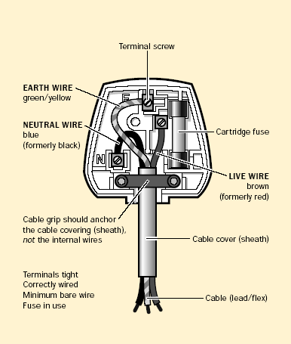

* **Earthed equipment will have a three core supply cable**
* **Live Brown to the Right**
* **Neutral Blue to the Left**
* **Earth**

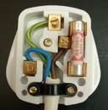

* **Double insulated equipment will have a two core supply**
* **Live**
* **Neutral**

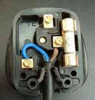

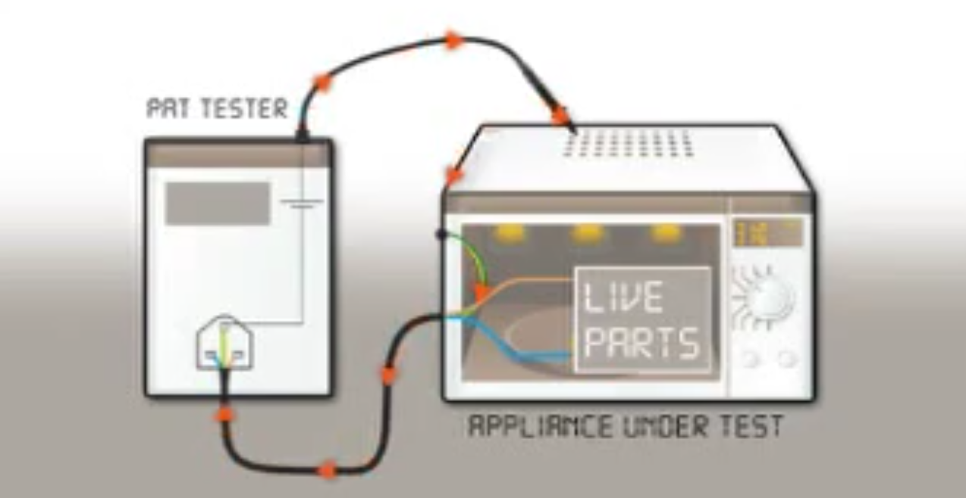

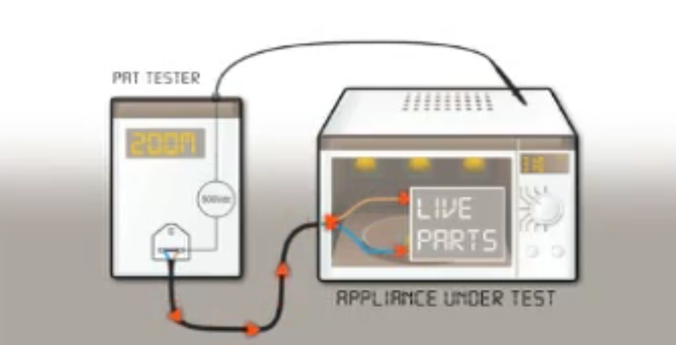

**Class II Test**

**Class I Test**