**Frequencies**

**8 kHz Follows gas pipes well for long distances sticks to cables will not bleed off so easily**

**33k VERY GOOD GENERAL PURPOSE best for clamps and induction receiver (10 paces)**

**8k Sonde Turn off most Sonde's on 37 kHz**

**9k Turn off as mixed frequency**

**8.33 Sonde Leave on**

**65k Leave on for petrol, chemical and gas pipes**

**131k Field trialled by B.T. as not earthed so B.T. force their own signal up the cables**

**131k can be used to coil cable around street lamps etc.**

**200k Petrol & chemical**

**POWER Locates loaded power cables**

**RADIO locates long metal objects over 25m**

**PASIVE Locates in POWER & RADIO simultaneously (1st locator to do this)**

**CATV Leave on - main use on plastic cables use TX10 to put a signal in to them for more accurate locate**

**CPS Used to trace oil & gas lines with electrical corrosion protection (100 HTZ)**

**ELF Turn off extra low frequency not very useful**

**RD Series 8000**

A Simple Guide



**Most used Frequencies**

**Power Radio Passive 33 Hz 8 Hz 131 Hz**

**Strike Alert Turn off on railways etc.**

**8K FF Ground faults (A-Frame)**

**256 Turn off not used in UK**

**285 Turn off not used in UK**

**320 On most used frequency**

**380 Turn off not used in UK**

**460 Turn off not used in UK**

**512 Turn off not used in UK (mainly USA)**

**640 On UK lowest frequency (lower the frequency the better it sticks)**

**640 Sonde Turn off if not using Sonde or camera**

**760 Turn off**

**From this point in the menu turn off all up to 8 kHz**

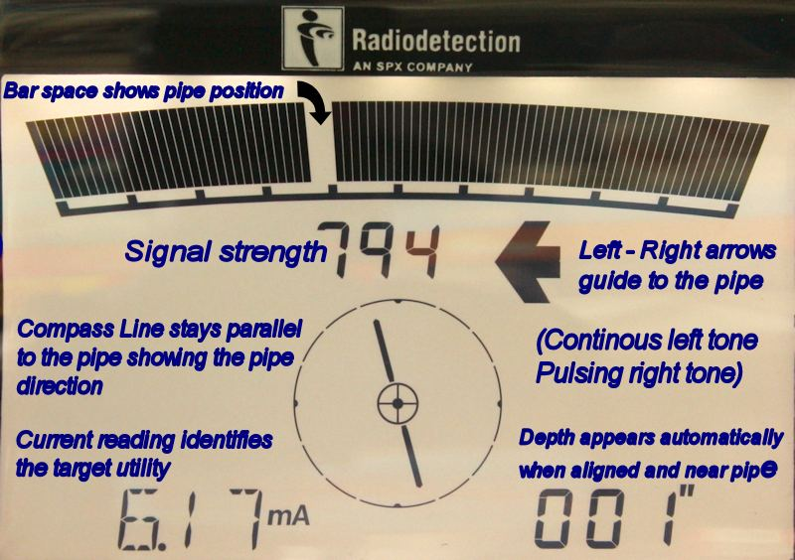

* **More powerful locator and transmitter**
* **More accurate locates**
* **Improved tracing**
* **Interactive menu**
* **Works in Power, Radio and Passive modes**
* **Multiple active frequencies (not just 33Htz)**
* **Approved by Network Rail & London Underground**





**ANT Antenna leave alone**

**POWER Check frequency set to 50htz but do not change**

**LANG Language DO NOT CHANGE!!!!**

**CAL Shows calibration date (lasts 1 year)**

**Peak and Null**

* **Peak better for congested areas**
* **Null better for less congested areas**
* **8k good for following main lines**
* **33khz good for following main lines with tees**

